Experiment 7: KNN Classification
Francis Reuben R
Department of Computer Science and Engineering, RV University
Data Science Laboratory, Semester 3, Section G | USN: 1RUA25CSE0168 | 27 October 2026

Objective
Classify a flower by the labels of its nearest neighbours. The notebook checks Euclidean and Manhattan distance, works one new flower by hand, fits sklearn KNN on the iris table, rebuilds the same vote in Python on sepal length and width, and then classifies 1,797 handwritten digits.

Description
The distance check uses the points (1, 1) and (5, 4). Euclidean distance is 5 and Manhattan distance is 7. The hand example has six flowers, each with petal length and petal width. The new flower has petal length 4.8 cm and petal width 1.7 cm, and K is 3. The three nearest are C (versicolor, 0.36), F (virginica, 0.36), and D (versicolor, 0.89). The vote is versicolor.
sklearn.datasets.load_iris supplies 150 rows and four measurements in centimetres: sepal length, sepal width, petal length, and petal width. Each species has 50 rows. The species codes are 0 setosa, 1 versicolor, and 2 virginica. The split for the sklearn model is 80/20 with random_state 1, which gives 120 training rows and 30 test rows (11 setosa, 13 versicolor, 6 virginica). KNeighborsClassifier uses K = 10 and the default Euclidean metric (Minkowski with p = 2). The same split is then scored for every K from 1 to 30. A sample row (4.8, 3.0, 1.5, 0.3) is scored with the K = 10 model.
The from-scratch vote keeps only sepal length and sepal width, so the classes overlap. That split is 70/30 with random_state 42: 105 training rows and 45 test rows (19 setosa, 13 versicolor, 13 virginica). K is 5. The label is the most common label among the five nearest training rows. sklearn is fit on that same split so the two votes can be compared.
sklearn.datasets.load_digits supplies 1,797 images of digits 0 to 9. Each image is 8 by 8 pixels, stored as 64 brightness values from 0 to 16. The split is 80/20 with random_state 10: 1,437 training rows and 360 test rows. K runs from 1 to 30. The confusion matrix and the classification report use the smallest K that reaches the highest test accuracy.

Flowchart
Figure 1 is the pipeline in Ex.No.7.ipynb. The charts from that notebook are Figures 2 to 8.
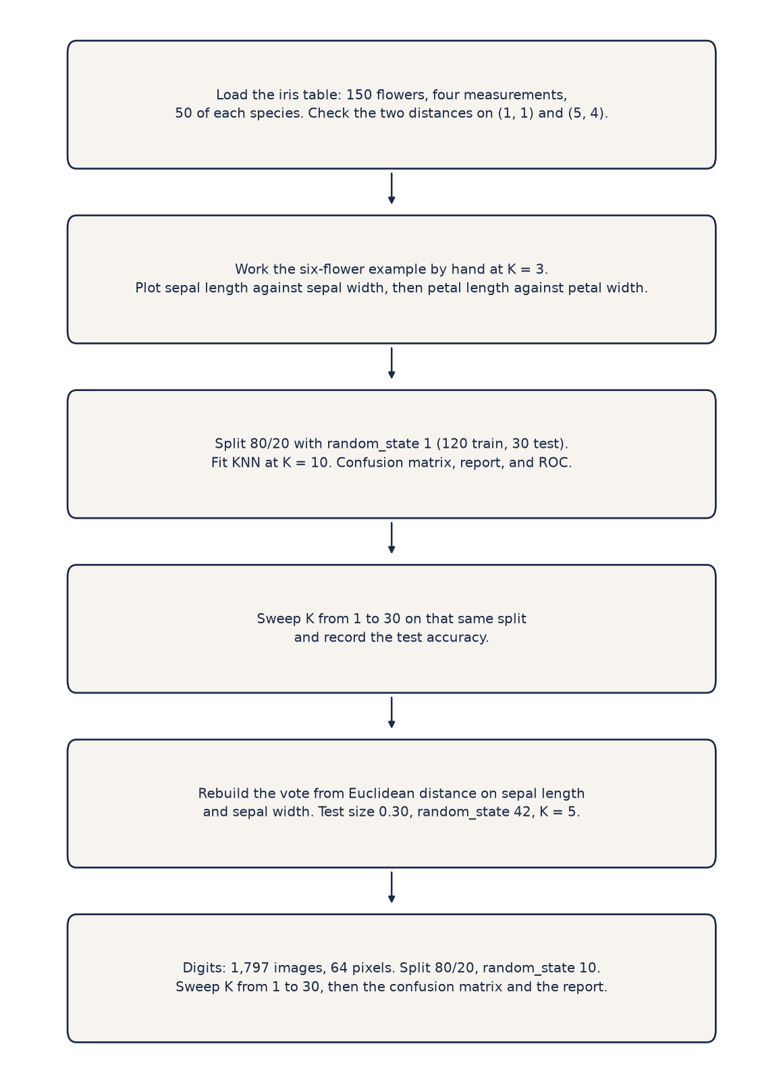
Figure 1. Pipeline for the hand example, the iris KNN model, the from-scratch vote, and the digits exercise.

Algorithm
- Start. Import pandas, numpy, matplotlib, seaborn, and scikit-learn.
- On (1, 1) and (5, 4), print the Euclidean distance and the Manhattan distance.
- For the six flowers, print the Euclidean distance to (4.8, 1.7), keep the three nearest, and take the majority species.
- Load the iris table. Add the species code and the species name. Plot setosa against versicolor on sepal axes and on petal axes, then plot all three species on the petal axes.
- Drop the species columns. Split 80/20 with random_state 1. Fit KNeighborsClassifier with K = 10. Print the test accuracy, the prediction for (4.8, 3.0, 1.5, 0.3), the confusion matrix, and the classification report.
- Plot the one-vs-rest ROC and print the macro AUC and the AUC of each class.
- On sepal length and sepal width only, split 70/30 with random_state 42. Predict with a Euclidean majority vote at K = 5. Print the accuracy, the classification report, and the number of rows where this vote differs from sklearn.
- Rebuild the 80/20 iris split and plot test accuracy for K = 1 to 30.
- Load the digits. Split 80/20 with random_state 10. Plot test accuracy for K = 1 to 30. Fit the K with the highest accuracy, print the confusion matrix, the classification report, and every off-diagonal pair.
- End.

Distance and the hand example
Euclidean distance on (1, 1) and (5, 4) is 5. Manhattan distance is 7. Both match the picture in the notebook: the straight line is 5, and the street path is 4 + 3 = 7.

Flower | Petal length | Petal width | Distance | Species
C | 4.5 | 1.5 | 0.36 | versicolor
F | 5.1 | 1.9 | 0.36 | virginica
D | 4.0 | 1.3 | 0.89 | versicolor
E | 5.8 | 2.2 | 1.12 | virginica
A | 1.4 | 0.2 | 3.72 | setosa
B | 1.3 | 0.3 | 3.77 | setosa
The three nearest are C, F, and D. Two are versicolor and one is virginica, so the prediction is versicolor. The computed distances are 0.3606, 0.3606, 0.8944, 1.1180, 3.7162, and 3.7696, which round to the values in the table.

Iris
Setosa is the small-petal species. Its mean petal length is 1.462 cm and its mean petal width is 0.246 cm. Versicolor and virginica sit close together on the petal axes: mean petal length 4.260 cm against 5.552 cm, mean petal width 1.326 cm against 2.026 cm. Sepal length and sepal width overlap, which is why a model that keeps only those two columns loses accuracy.

Species | Sepal length | Sepal width | Petal length | Petal width
setosa | 5.006 | 3.428 | 1.462 | 0.246
versicolor | 5.936 | 2.770 | 4.260 | 1.326
virginica | 6.588 | 2.974 | 5.552 | 2.026
Means are in centimetres, over the 50 rows of each species. Figure 2 is sepal length against sepal width for setosa and versicolor. The two clouds meet. Figure 3 is petal length against petal width for all three species. Setosa is separate. Versicolor and virginica share a boundary, which is where the later error sits.
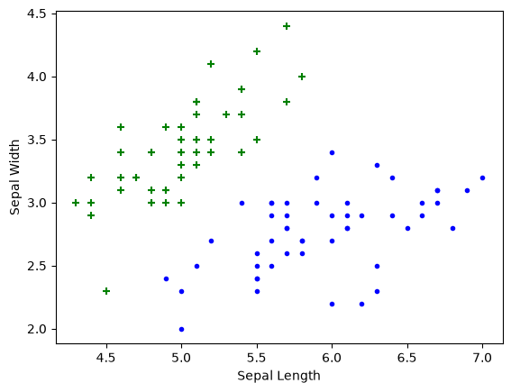
Figure 2. Sepal length against sepal width. Green crosses are setosa. Blue dots are versicolor.
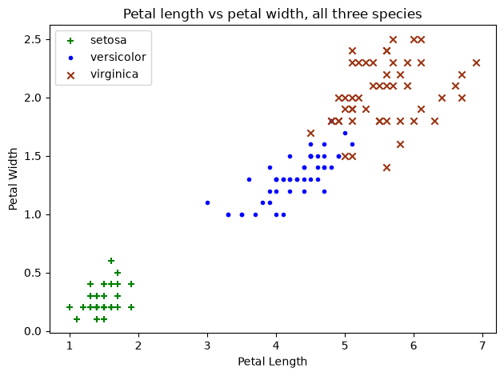
Figure 3. Petal length against petal width for setosa, versicolor, and virginica.

K = 10 on four measurements
On the 30 test rows the accuracy is 0.9667, which is 29 of 30. The classification report prints this as 0.97. The sample (4.8, 3.0, 1.5, 0.3) is predicted as class 0, setosa. Setosa is perfect on this fold: precision 1.00, recall 1.00, 11 of 11. Versicolor recall is 0.92 (12 of 13). Virginica precision is 0.86 (6 of 7), because the one miss is a versicolor called virginica.

Class | Precision | Recall | F1 | Support
0 setosa | 1.00 | 1.00 | 1.00 | 11
1 versicolor | 1.00 | 0.92 | 0.96 | 13
2 virginica | 0.86 | 1.00 | 0.92 | 6
Figure 4 is that confusion matrix. The single off-diagonal entry is row 77 of the iris table, a versicolor with sepal length 6.7, sepal width 3.0, petal length 5.0, and petal width 1.7. Its ten neighbours vote 6 virginica and 4 versicolor, so the predicted probabilities are 0.60 and 0.40.

Row | True label | Predicted | P(versicolor) | P(virginica)
77 | versicolor | virginica | 0.40 | 0.60

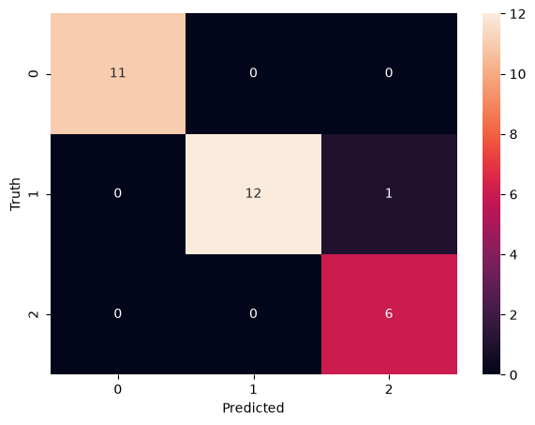
Figure 4. Confusion matrix for iris, K = 10, on the 30 test rows. Labels are 0, 1, and 2.

ROC
The one-vs-rest ROC in Figure 5 has AUC 1.000 for setosa, versicolor, and virginica. The macro AUC is 1.000. The curve uses the class probabilities, not only the final vote. Row 77 is still counted wrong in the accuracy, because virginica's probability is 0.60 and versicolor's is 0.40, while the ranking of each class score on this test set remains perfect.
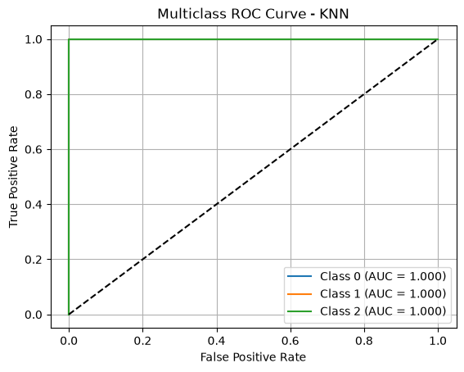
Figure 5. One-vs-rest ROC for the K = 10 iris model. Each class has AUC 1.000.

Choosing K
The rule of thumb in the notebook is K near the square root of the training size. The square root of 120 is about 11. On this 30-row test, K = 1, 2, 3, 4, 5, 6, and 8 score 30 of 30. K = 7 and every K from 9 to 30, including the fitted K = 10 and the rule-of-thumb K = 11, score 29 of 30. The sweep reports K = 1 as the best because it is the first maximum. One flower is the whole gap between 1.000 and 0.967, so the flat line in Figure 6 is that same miss, not a slow decline.

K | Correct | Accuracy
1, 2, 3, 4, 5, 6, 8 | 30 of 30 | 1.000
7 | 29 of 30 | 0.967
9 through 30, including 10 and 11 | 29 of 30 | 0.967

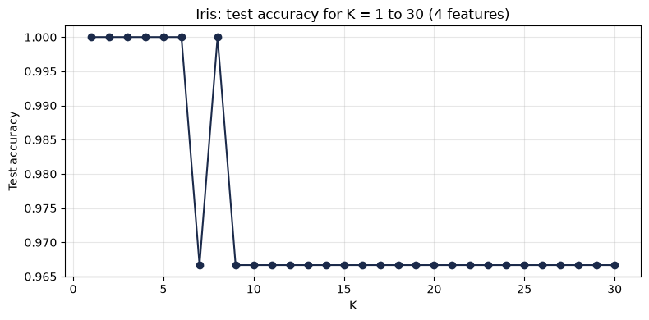
Figure 6. Iris test accuracy for K = 1 to 30 on the 120/30 split, four measurements.

KNN from scratch
With only sepal length and sepal width, K = 5 is right on 36 of the 45 test rows, accuracy 0.80. Setosa is still perfect (19 of 19). Versicolor recall is 0.62 (8 of 13) and virginica recall is 0.69 (9 of 13). Figure 7 shows the mix: 5 versicolor called virginica, and 4 virginica called versicolor.

Class | Precision | Recall | F1 | Support
setosa | 1.00 | 1.00 | 1.00 | 19
versicolor | 0.67 | 0.62 | 0.64 | 13
virginica | 0.64 | 0.69 | 0.67 | 13

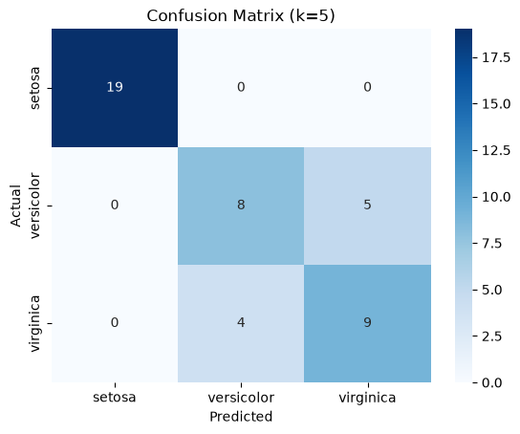
Figure 7. From-scratch confusion matrix on sepal length and sepal width, K = 5, 45 test rows.
sklearn on the same rows and the same K scores 35 of 45, accuracy 0.7778. The two votes differ on one virginica whose sepal length is 6.5 and sepal width is 3.0. Two training virginicas sit on that same point (distance 0). One versicolor at (6.6, 3.0) is 0.10 away. Three further flowers are tied at distance 0.1414: a virginica at (6.4, 3.1) and versicolors at (6.4, 2.9) and (6.6, 2.9). K = 5 has room for only two of those three. The scratch sort takes the virginica and one versicolor, the vote is 3 to 2 for virginica, and the call is correct. sklearn takes the two versicolors, the vote is 3 to 2 for versicolor, and the call is wrong. The accuracy curve for the scratch vote stays between 0.733 (33 of 45) and 0.800 (36 of 45) for K = 1 to 20. The high value 0.800 is reached at K = 5, 6, 7, 9, and 20.

Handwritten digits
K = 1 and K = 3 both score 356 of 360, accuracy 0.9889. The sweep reports K = 1, the first maximum, and the confusion matrix is built at that K. K = 5 scores 355 of 360 (0.9861). K = 11, near the square root of the iris training size and not of this one, scores 353 of 360 (0.9806). The lowest point in the sweep is K = 27 at 342 of 360 (0.9500). K = 30 scores 344 of 360 (0.9556). On this test set the small values of K are the accurate ones.

K | Correct | Accuracy
1 and 3 | 356 of 360 | 0.9889
5 | 355 of 360 | 0.9861
11 | 353 of 360 | 0.9806
27 | 342 of 360 | 0.9500
30 | 344 of 360 | 0.9556
Figure 8 is the confusion matrix at K = 1. Four test images are wrong, each pair once: an 8 read as 1, an 8 read as 3, a 9 read as 3, and a 9 read as 4. Digits 0, 2, 5, 6, and 7 are perfect. Digit 8 is the weakest: 31 of 33 correct, recall 0.939, F1 0.969. Digit 9 is next: 37 of 39 correct, recall 0.949, F1 0.974. The printed report rounds both F1 scores to 0.97. Digit 3 has precision 0.952 because it receives one 8 and one 9.

Digit | Precision | Recall | F1 | Support
0 | 1.000 | 1.000 | 1.000 | 37
1 | 0.971 | 1.000 | 0.986 | 34
2 | 1.000 | 1.000 | 1.000 | 34
3 | 0.952 | 1.000 | 0.976 | 40
4 | 0.971 | 1.000 | 0.986 | 34
5 | 1.000 | 1.000 | 1.000 | 32
6 | 1.000 | 1.000 | 1.000 | 37
7 | 1.000 | 1.000 | 1.000 | 40
8 | 1.000 | 0.939 | 0.969 | 33
9 | 1.000 | 0.949 | 0.974 | 39

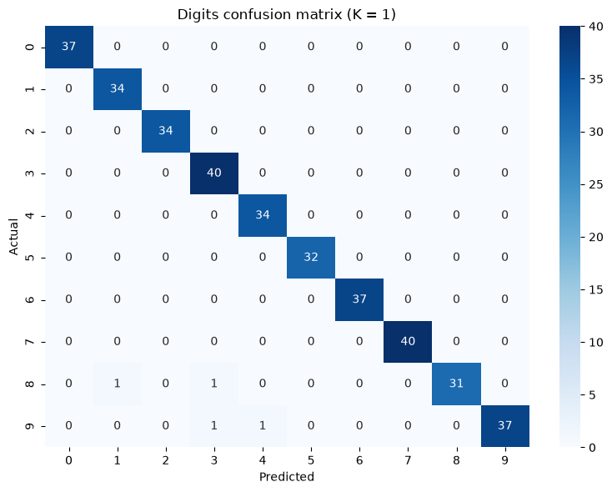
Figure 8. Digits confusion matrix at K = 1 on the 360 test images.

Result
The hand example at K = 3 predicts versicolor: the three nearest flowers are two versicolor and one virginica. On the iris table, four measurements and K = 10 classify 29 of the 30 test flowers. The miss is row 77, a versicolor whose ten neighbours vote 6 to 4 for virginica. The one-vs-rest AUC is 1.000 for every species. K from 1 to 6 and K = 8 score all 30 test flowers, and K from 9 to 30 scores 29. A vote built from sepal length and sepal width alone reaches 36 of 45 at K = 5. sklearn on that split reaches 35 of 45, and the one-row gap is a three-way distance tie at 0.1414. On the digits, K = 1 and K = 3 both score 356 of 360. The four mistakes are two 8s and two 9s, and digit 8 has the lowest F1 at 0.969.

GitHub
Course repository: https://github.com/francisreubenr-rvu/Data-Science-Labs
The executed notebook is Ex.No.7.ipynb in Semester-3/Labs-Semester-3/Lab 07. The upload copy is 1RUA25CSE0168_Francis_Reuben_R_Lab7.ipynb. Outputs are saved in the file.

